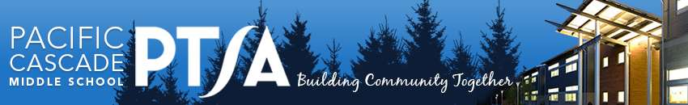

**PCMS PTSA Curriculum Enrichment Grant Application**

Pacific Cascade Middle School PTSA offers Curriculum Enrichment Grants to provide additional resources for PCMS staff, supporting educational enrichment and opportunities in the current academic year. Grants are evaluated on *NEED, ENRICHMENT,* and *IMPACT*. All eligible applications are reviewed by the Grants Committee who make a recommendation to the PTSA Board of Directors for a vote.

Applicant(s):

*Contact E-mail*:

*Total Funds Requested*, including taxes, shipping, and other funding sources: student or school paid portion, district funds, ISF grants, previous grants:

*Specific Grant Request Description and NEED:*

*ENRICHMENT*: Describe educational qualities and merit of request?

*IMPACT:* How many students will be impacted by this Grant? Grade level(s)?

Additional Comments:

Complete all questions, attaching additional receipts, documentation, order details to fulfill application. Forward completed applications to the PCMS front office, attention: PTSA. Alternatively email completed applications to Laura Gaffney [LGaffney@outlook.com](mailto:LGaffney@outlook.com)

Date of Submission:

Applicant Signature:

Principal Signature:

(Attach email confirmation of grant approval request, if necessary.)